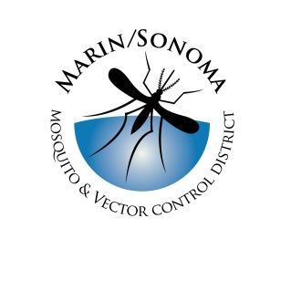
Marin/Sonoma Mosquito & Vector Control District
Source Reduction/Wastewater Specialist: Supplemental Questions

Directions: Provide your answers by typing responses directly within this Microsoft Word document or attaching a separate sheet(s).

- Please describe your knowledge of the principles of source reduction work pertaining to mosquito control.

- What has been your “hands-on” expertise (if any) in mosquito source reduction work?

- What experience have you had (if any) providing services directly to members of the public, including dealing with landowners and public agencies?

- Safe working practices are a top priority at the District. Have you had any experience and/or training in safety practices and procedures?

- Have you had training and/or experience in working with municipal wastewater and/or treated irrigation water?

