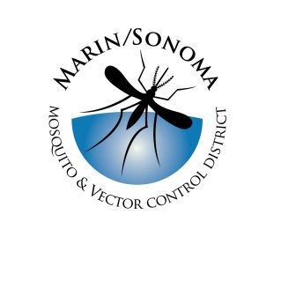
Marin/Sonoma Mosquito & Vector Control District
Mechanic/Facilities Manager Application: Supplemental Questions

Directions: Provide your answers by typing responses directly within this Microsoft Word document or attaching a separate sheet(s).

- Please briefly describe your mechanical expertise, including experience in vehicle maintenance.

- Have you had any experience in welding, fabricating parts and/or maintaining and calibrating specialized equipment e.g. off-road vehicles, watercraft, gas pumps, diesel equipment etc.?

- Briefly describe your experience (if any) as a supervisor or manager, including dealing with personnel matters.

- Please list any qualifications and/or experience in safe working practices, injury & spill prevention, dealing with hazardous materials, state & local agency permit requirements etc.

- Summarize your experience maintaining facilities, such as carpentry, electrical, plumbing, working on grounds, pavement etc.

- List any experience preparing or administering bids, budgets and contracts.

