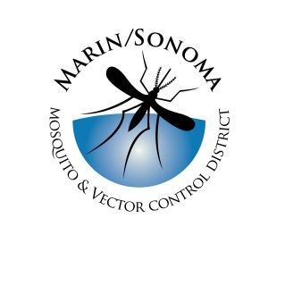
Marin/Sonoma Mosquito & Vector Control District
Rodent Control Specialist: Supplemental Questions

Directions: Provide your answers by typing responses directly within this Microsoft Word document or attaching a separate sheet(s).

- Please describe briefly how you gained your knowledge of the principles of rodent control work.

- Are you certified by the CA Department of Public Health as a Vector Control Technician in the Vertebrates of Public Health significance (Category D)? If not, do you have other qualifications?

- What has been your “hands-on” experience (if any) in dealing with problems caused by rodents?

- What experience have you had (if any) providing pest/vector control services directly to members of the public, including dealing with landowners and public agencies?

- Safe working practices are a top priority at the District. Have you had any experience and/or training in safety practices and procedures?

